W03 Project: Rafting Site - Planning Document – Gabriel Amorim

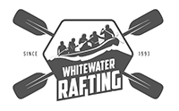

* primary color - Carolina blue (86bbd8)
* secondary color - Moss green (758e4f)
* accent1-color – Orange(pantone) (f26419)
* accent2-color – Lapis lazuli (33658a)

https://coolors.co/palette/33658a-86bbd8-758e4f-f26419

* heading-font - Inter (https://fonts.google.com/specimen/Inter)
* text-font – Open Sans (https://fonts.google.com/specimen/Open+Sans)